Nom : ABA

Prénom : ACHI SERGE

# **TP2 :**

1. In what kind of memory the bytecode is stored ?

Le bytecode d'un contrat Solidity est stocké dans la mémoire de la blockchain Ethereum,

# 3. Primitive Data Types

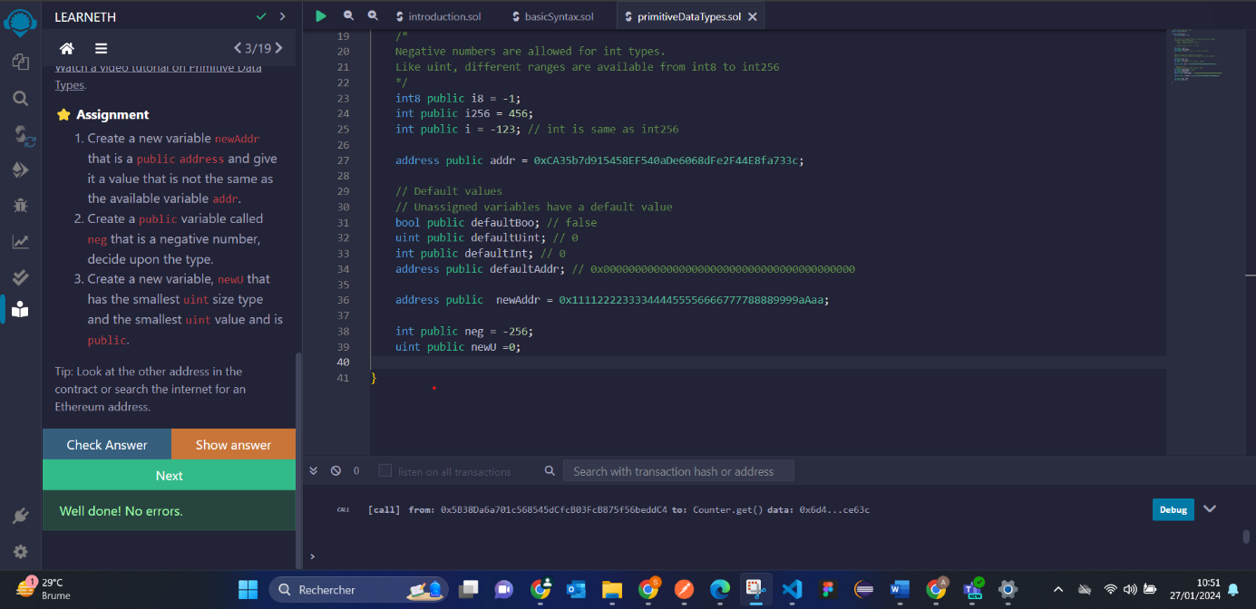

# 4. Variables

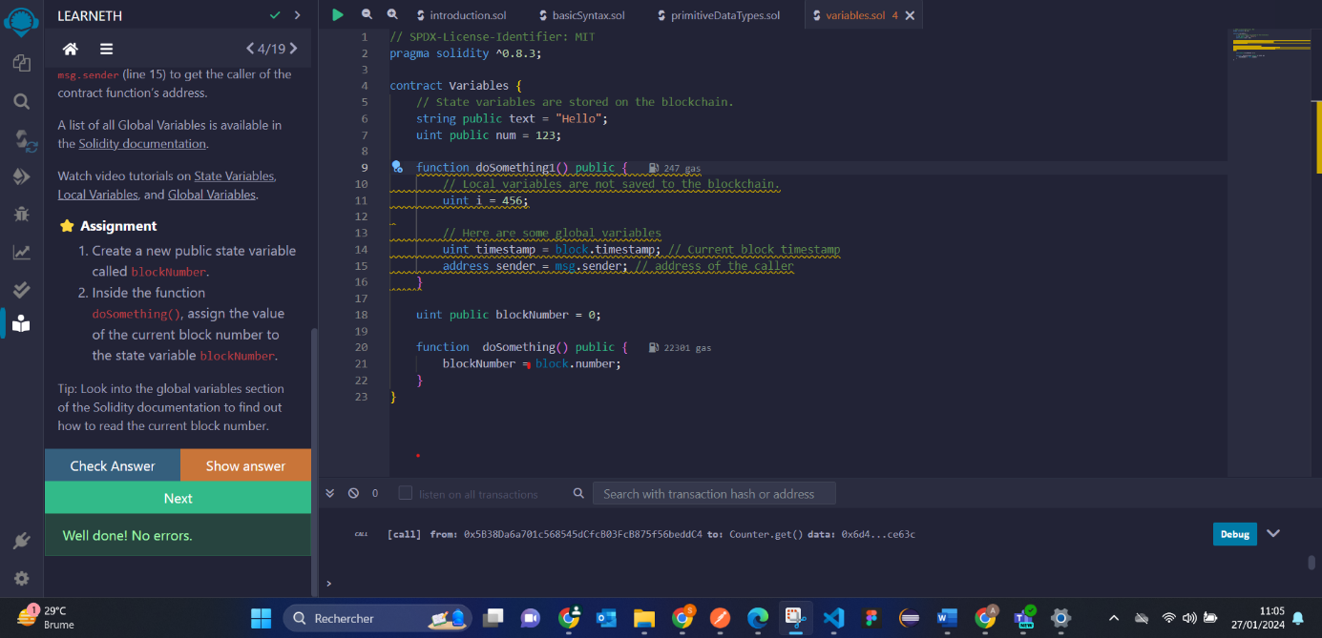

# 5.1 Functions - Reading and Writing to a State Variable

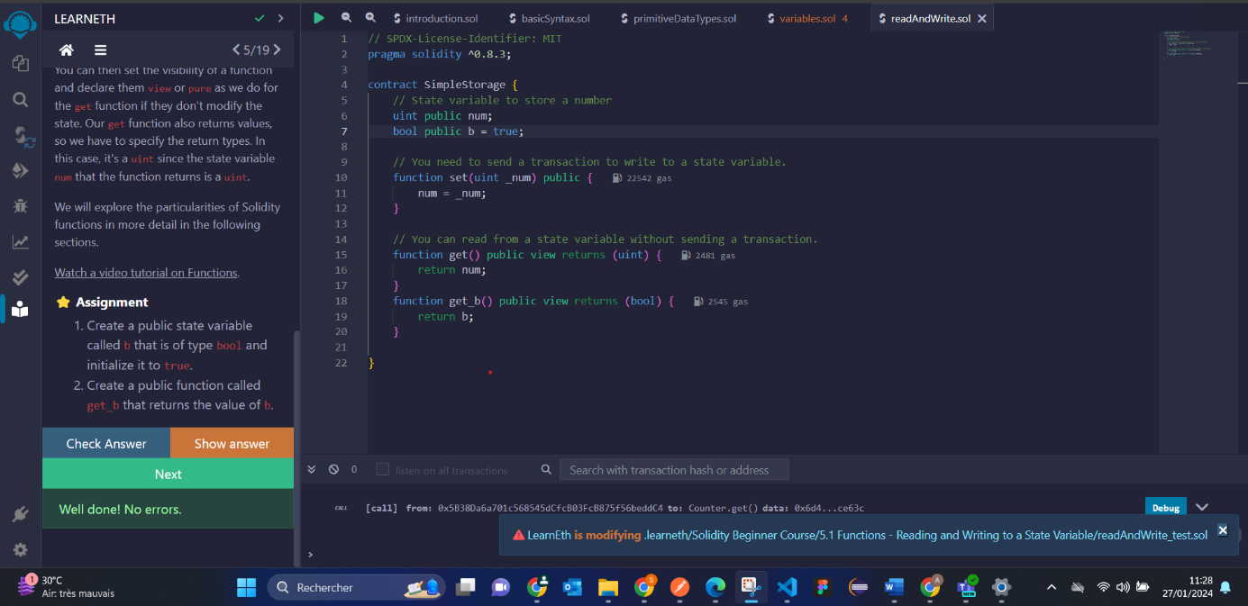

# 5.2 Functions - View and Pure

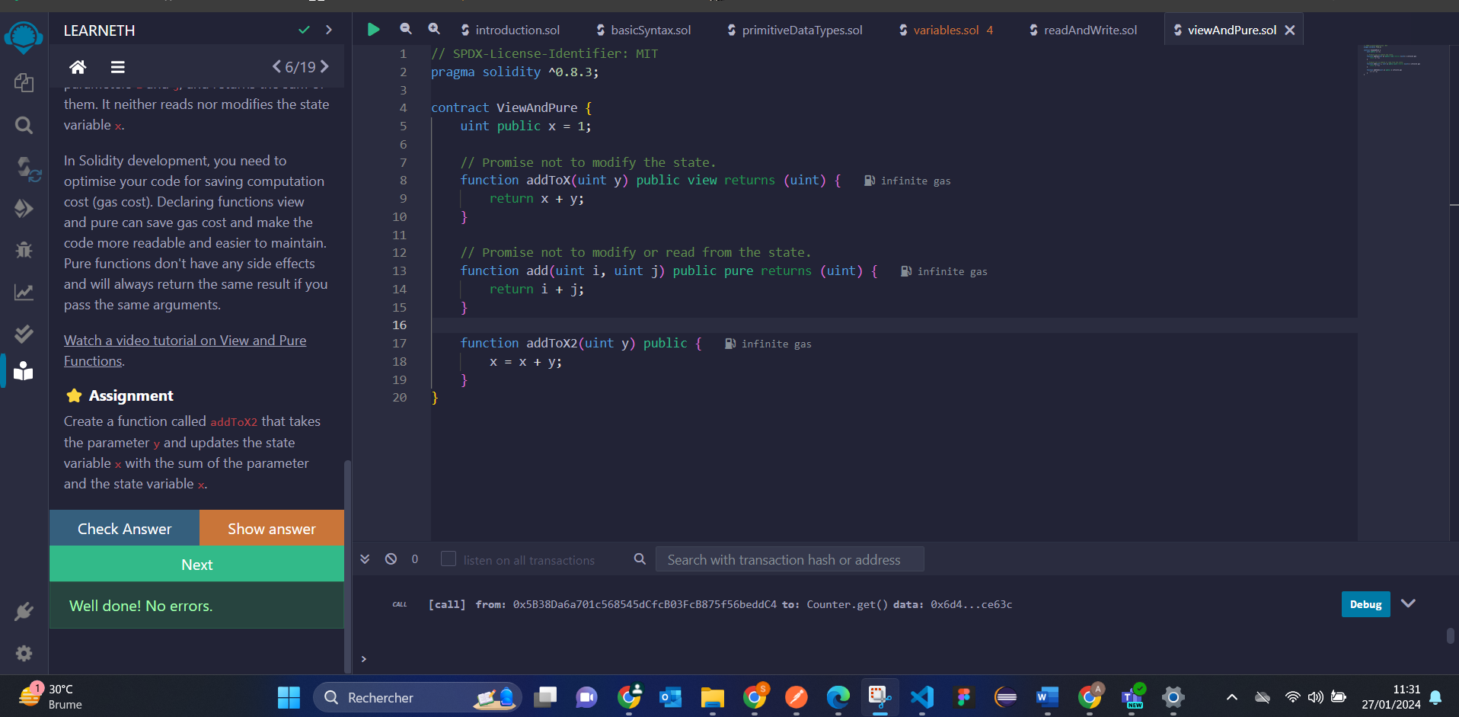

# 5.3 Functions - Modifiers and Constructors

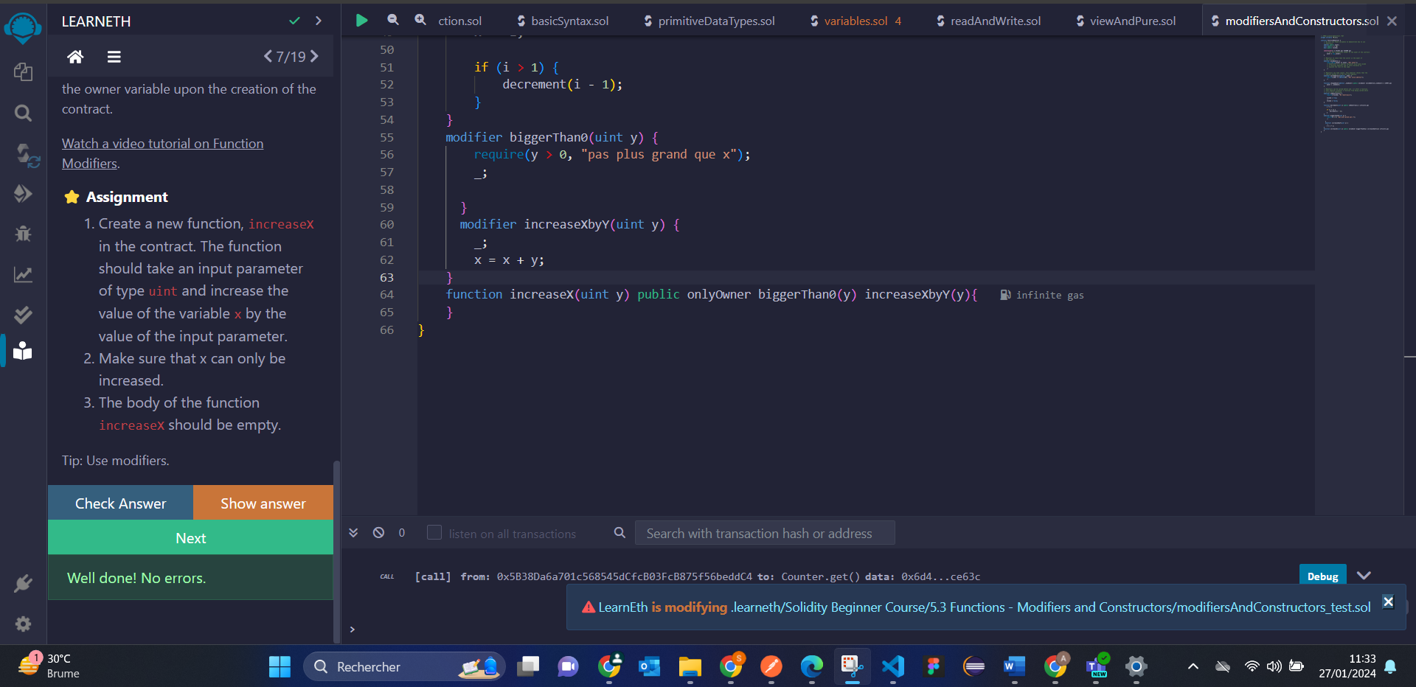

# 5.4 Functions - Inputs and Outputs

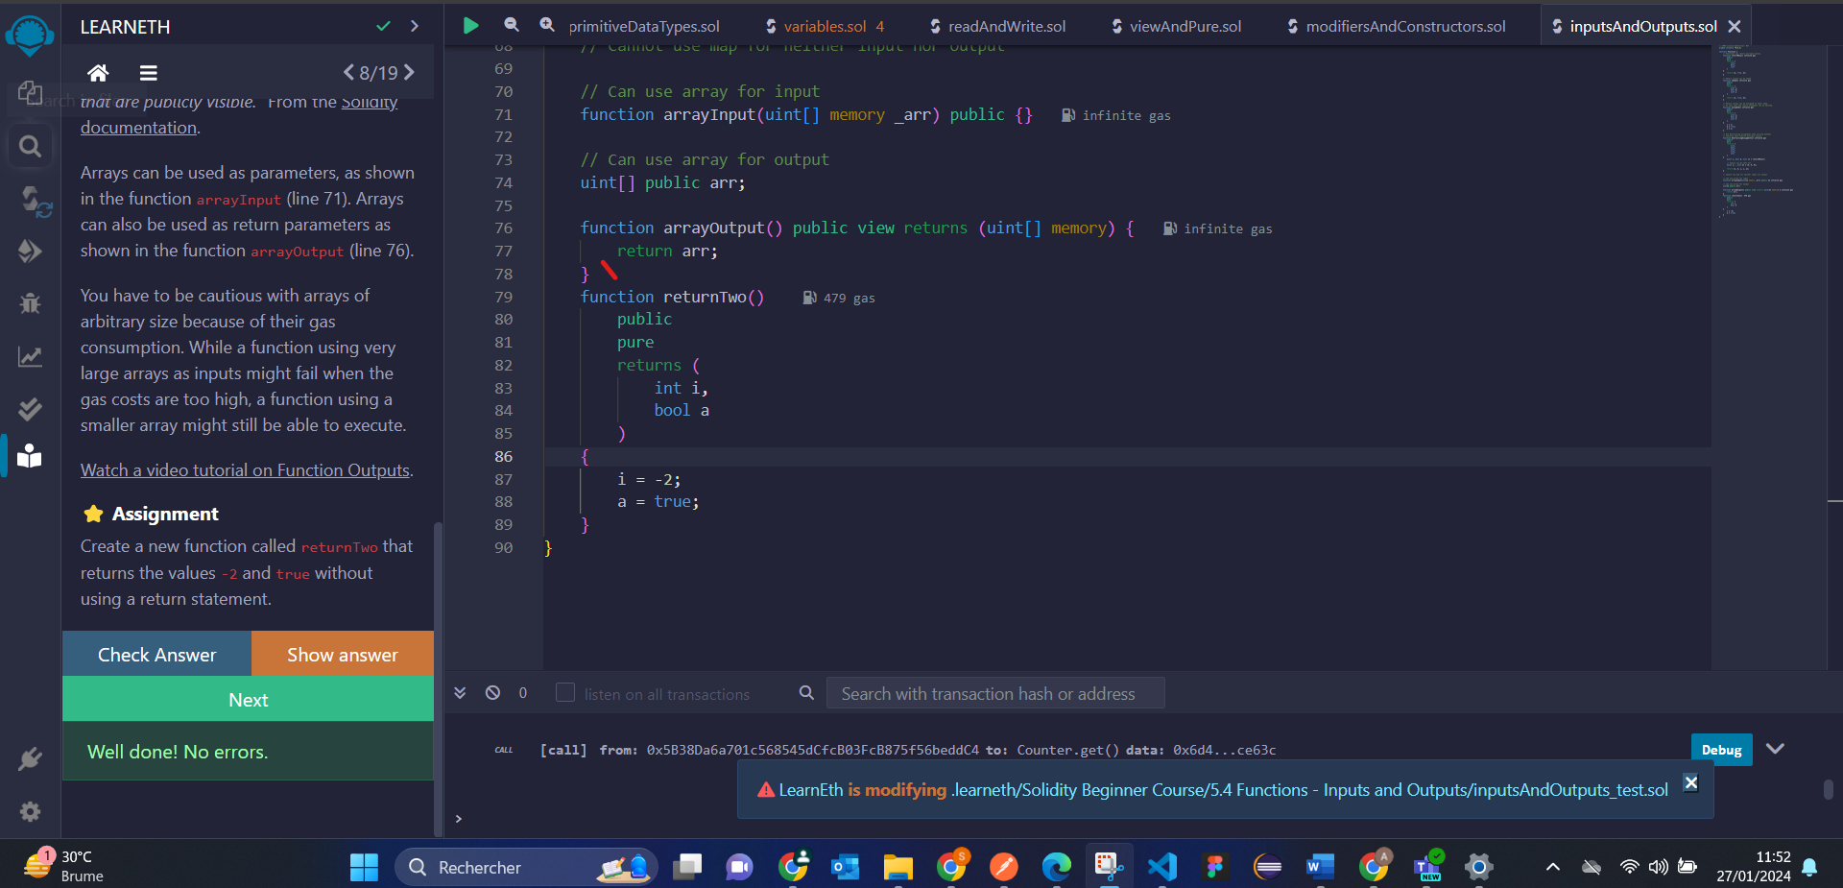

# 6. Visibility

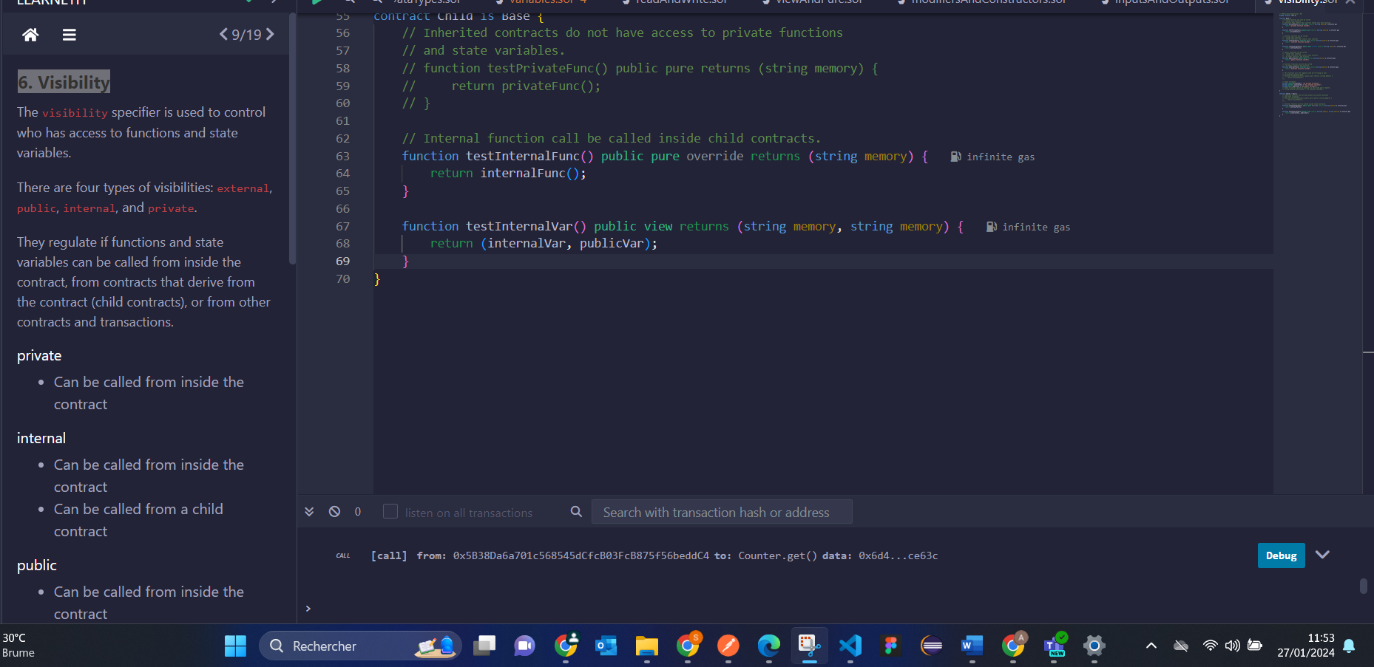

# 7.1 Control Flow - If/Else

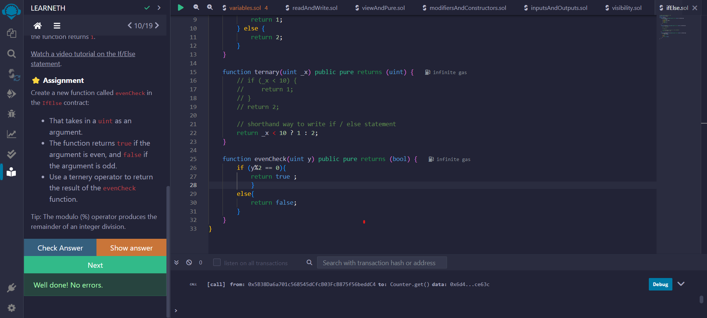

# 7.2 Control Flow - Loops

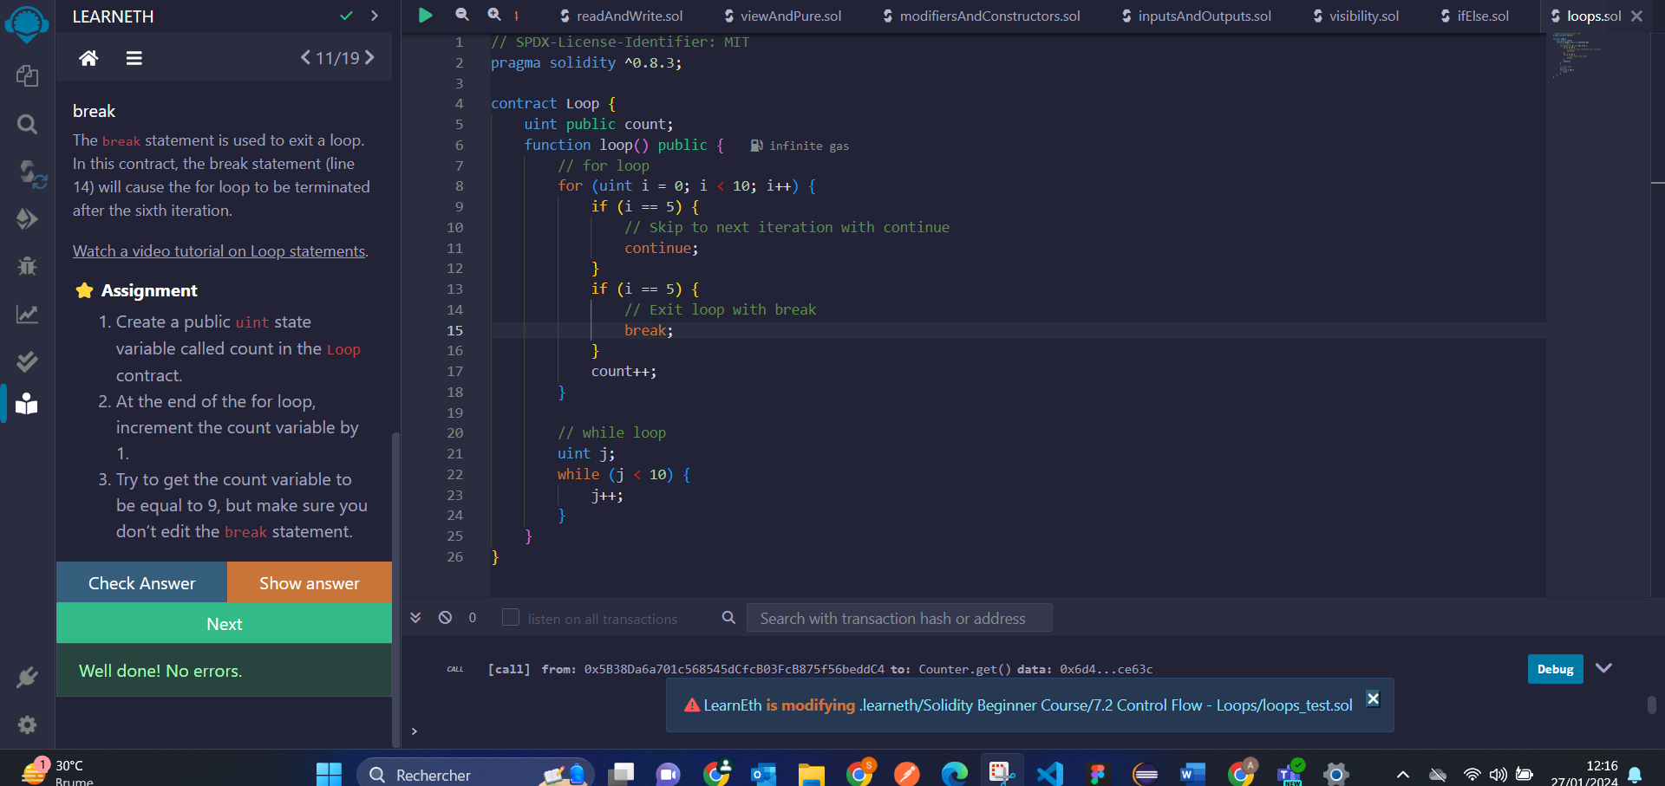

# 8.1 Data Structures - Arrays

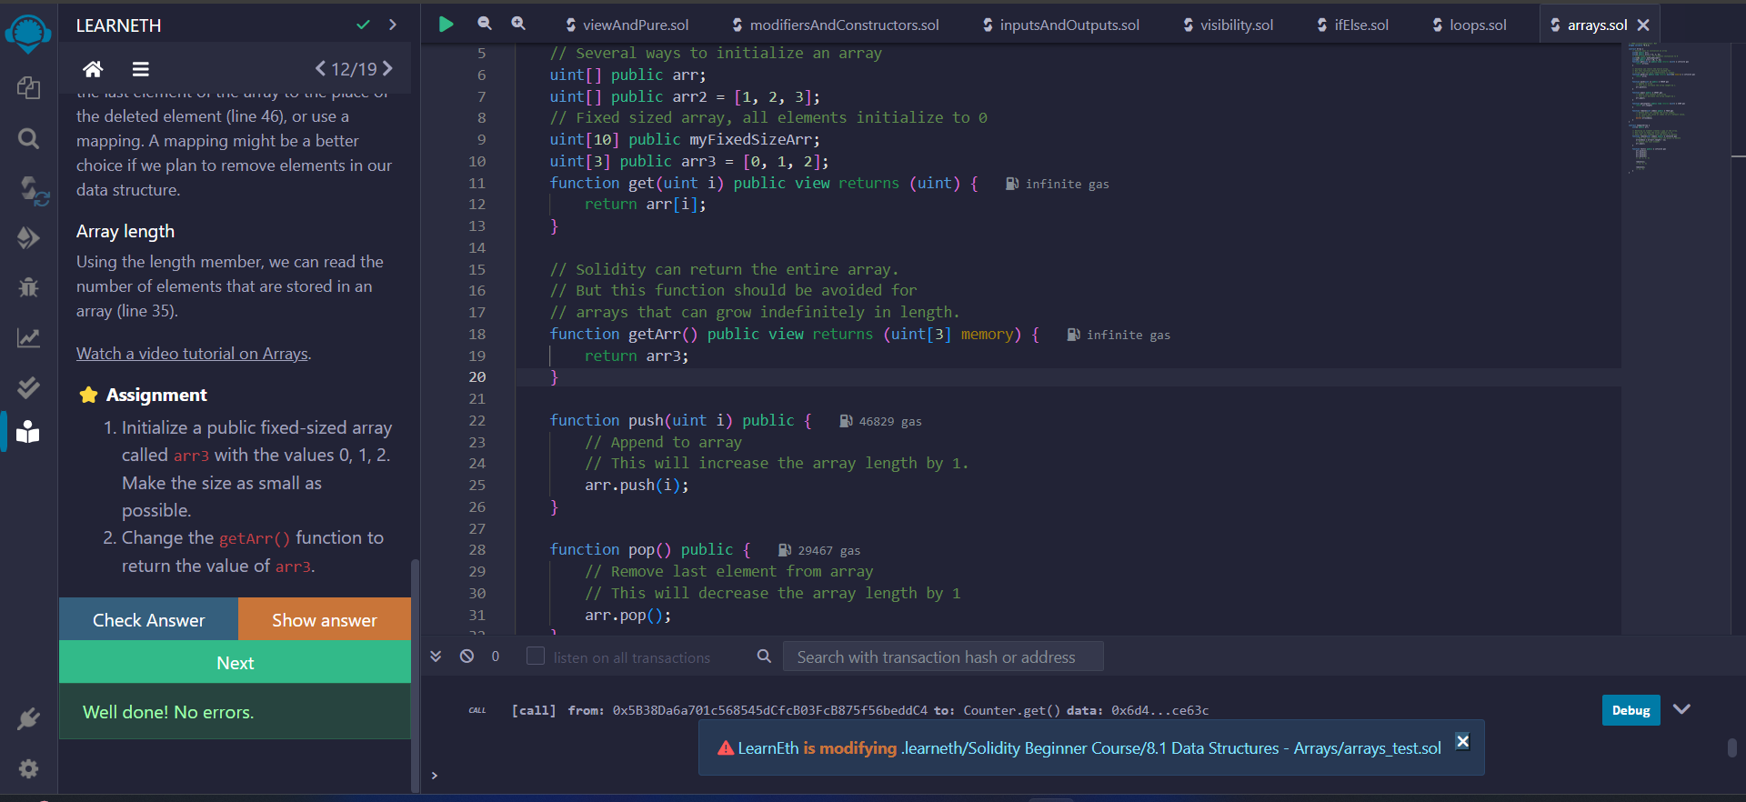

# 8.2 Data Structures - Mappings

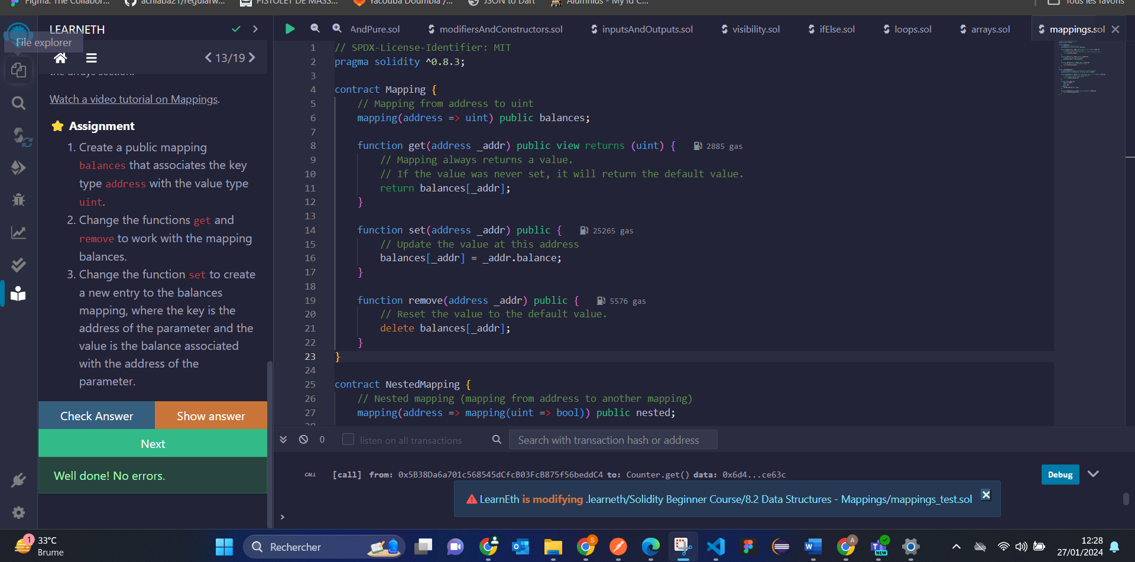

# 8.3 Data Structures - Structs

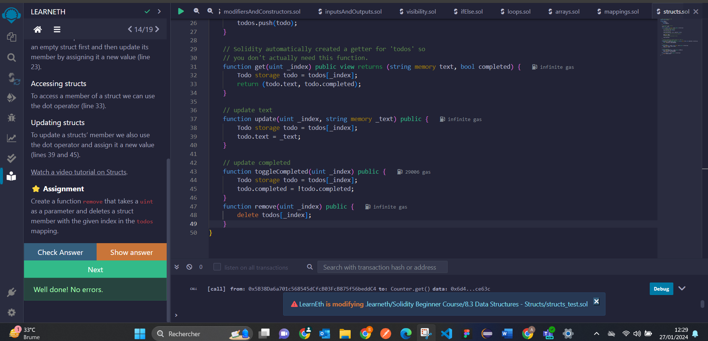

# 8.4 Data Structures - Enums

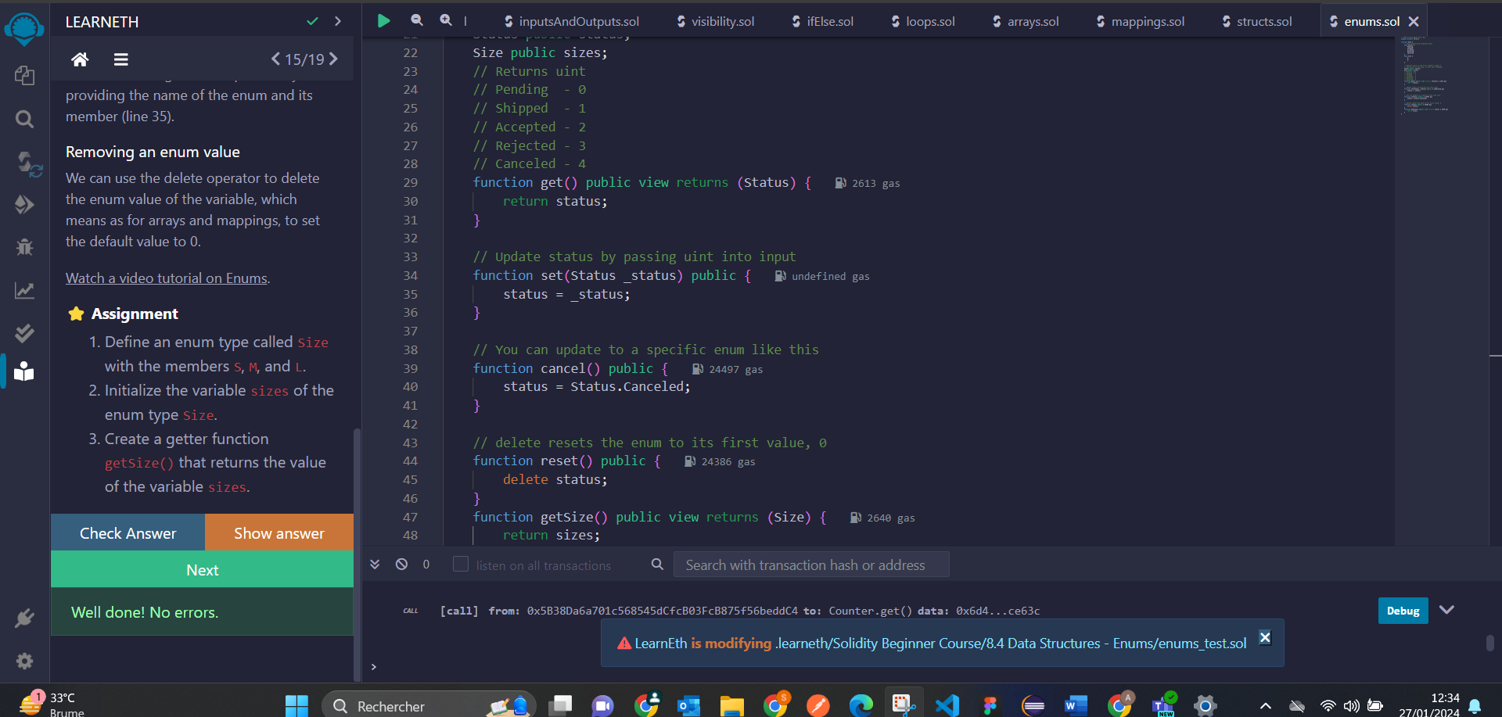

# 9. Data Locations

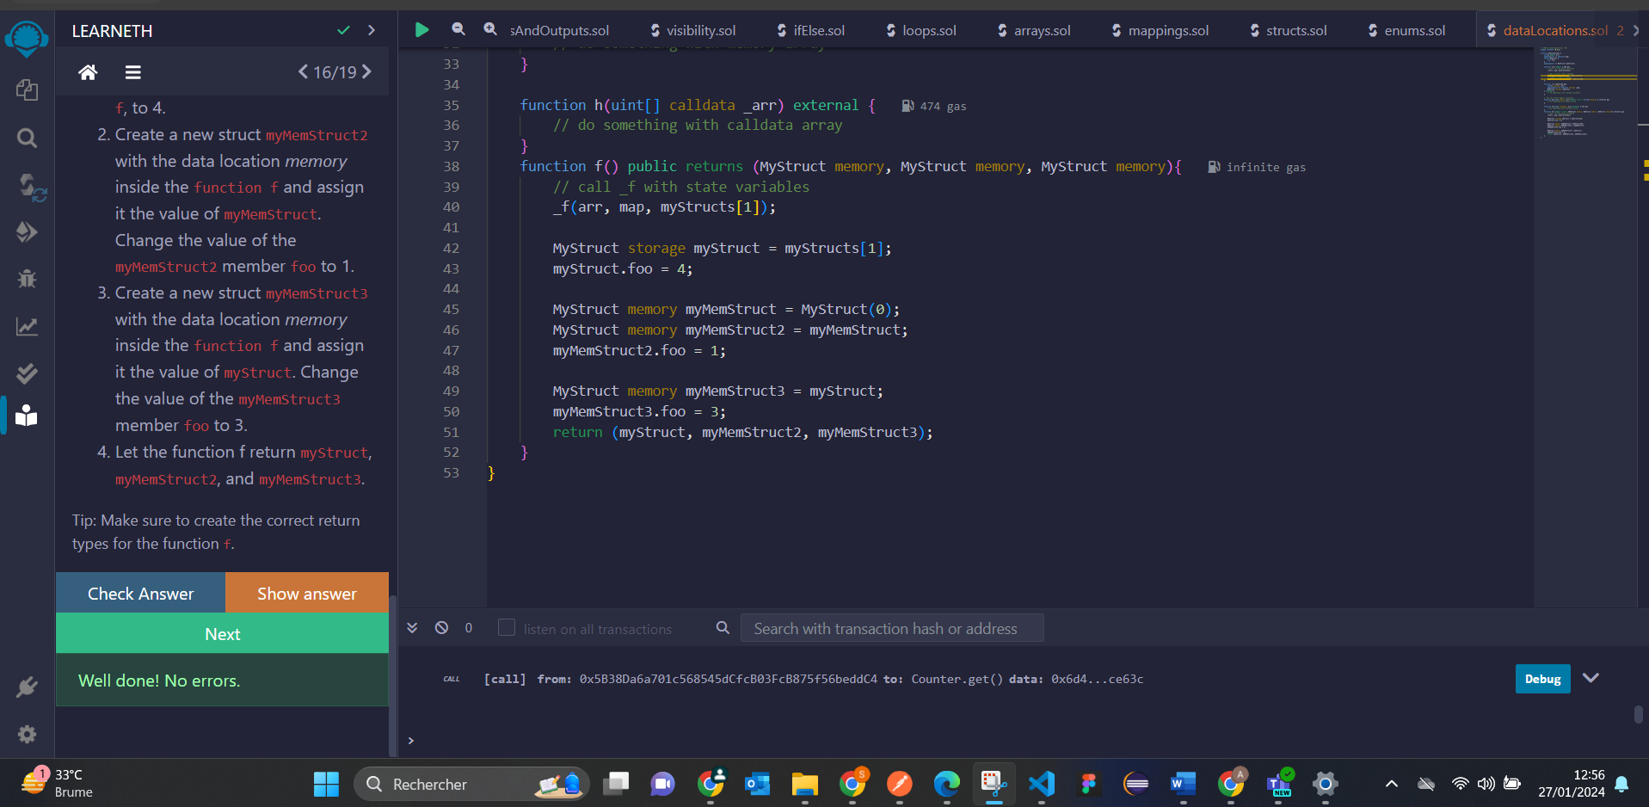

# 10.1 Transactions - Ether and Wei

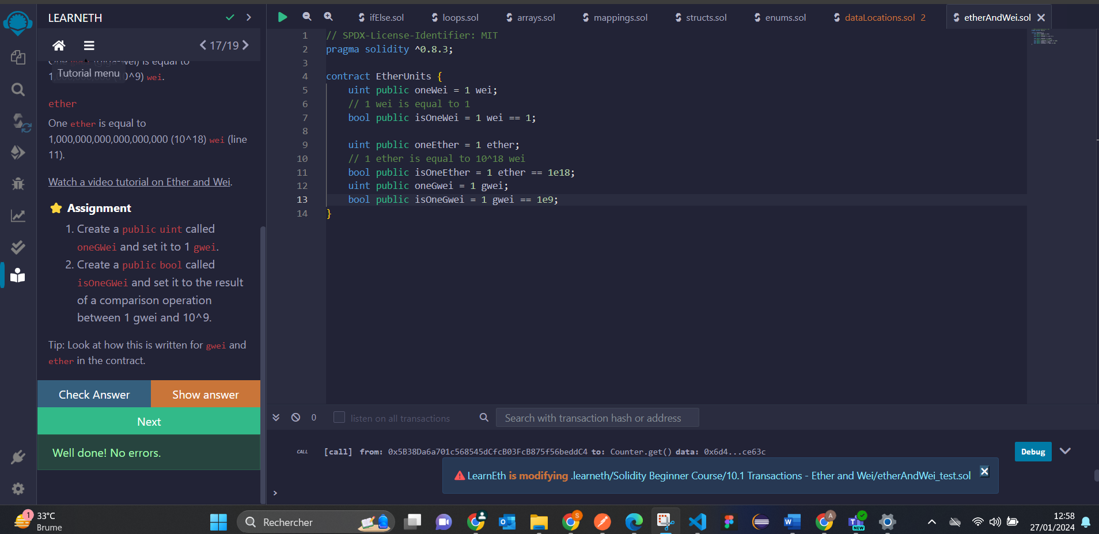

# 10.3 Transactions - Sending Ether

